Failure Mode and Effects Analysis (FMEA)

# 1. Project Information

| Field | Description |
| --- | --- |
| Project File | [Filling Machine.FCStd](https://drive.google.com/drive/u/0/folders/1OKUz92ybT7GK3S2otr5JG4uh0ir2Ukvb) |
| Revised Project File | [Final Project](https://drive.google.com/file/d/19r6IA3jAfzVS2BZ9Hmmp7oL6e31y6XSd/view?usp=share_link) |
| FMEA Team Leader | Ryan Kelly |

# 2. Project Description

This project focuses on designing a **Portable Manual Liquid Filling Machine** for laboratory, field, and small-batch industrial use. The device addresses the limitations of existing filling methods, which are often **slow, inconsistent, and prone to spills** when using funnels, syringes, or pipettes. Unlike large-scale filling machines that are costly and non-portable, this design prioritizes **efficiency, precision, affordability, and mobility**.

#### **How It Works**

* **Fill:** Remove the top fill cap, pour liquid into the chamber, and replace the cap.
* **Position:** Place the container under the nozzle, using the side handle for stability.
* **Dispense:** Push the plunger to release liquid through the nozzle.
* **Clean:** Disassemble parts, rinse, and dry after use.

#### **Design Features & Goals**

* **Quick Operation:** One-handed plunger action; accurate filling for 10 mL to 100 mL.
* **Interchangeable Nozzles:** Snap-on options for test tubes, bottles, or vials.
* **Easy Cleaning:** All fluid-contact parts snap apart for maintenance.
* **Cost Efficiency:** Target price under $100/unit using common, durable materials.

**Material Summary:**

* Housing & Reservoir: Polycarbonate
* Frame & Lever: ABS
* Nozzles: Polypropylene or 316L Stainless Steel
* Seals/Tubing: Silicone

#### **Target Users**

* **Academic Researchers & Lab Technicians:** For precise, small-volume liquid handling in space-limited environments.
* **Field Scientists & Environmental Technicians:** Portable design suited for mobile sampling in rugged conditions.
* **Small-Batch Manufacturers (Food, Cosmetics, Beverage):** Affordable filling solution for QA sampling or boutique production.
* **Healthcare & Veterinary Professionals:** Assists in dosing and sample preparation for clinics or on-site visits.

#### **Why This Device?**

Existing machines are **large and costly**, making them impractical for small-scale operations. This device combines **portability and precision**, filling a crucial gap for users who need an **affordable, flexible, and hygienic** solution.

#### **Safety & Maintenance**

* **Safety:** Inspect seals before use; do not exceed fill limits; stop if any part is damaged.
* **Maintenance:** Regular cleaning; check alignment of guide rods; replace worn seals and fasteners as needed.

**Filling Machine**

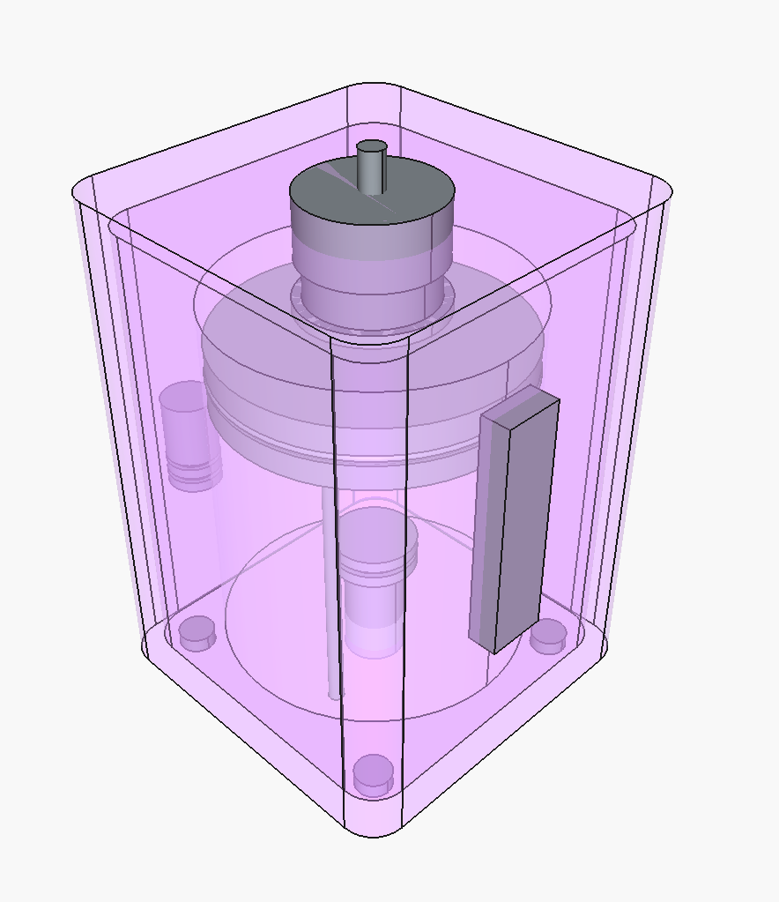

# 3. FMEA Worksheet

This table outlines the core components of the FMEA, including potential failure modes, their effects, causes, and proposed actions.

| Potential  Failure  Mode | Potential Effect(s) of Failure | Severity (S) | Occurrence (O) |  | Detection (D) | RPN (S x O x D) | Mitigation |
| --- | --- | --- | --- | --- | --- | --- | --- |
| Overfilling the reservoir | Spillage, contamination risk, operator injury (slip hazard) | 7 | 5 |  | 3 | 7x5x3 = 105 | Add clear fill line indicator; include instructions on max fill volume |
| Plunger jams or sticks | Inconsistent fill | 8 | 2 |  | 1 | 8x2x1 = 16 | Ensure smooth plunger fit; use low-friction materials; add maintenance checks |
| Seal failure (worn or misaligned) | Leakage, inaccurate dosing, contamination | 8 | 5 |  | 4 | 8x5x4 = 160 | Use FDA-grade seals; schedule regular inspection and replacement |
| Nozzle disconnects during use | Spillage, contamination, product loss | 6 | 2 |  | 6 | 6x2x6 = 72 | Design threaded or locking nozzle connection; perform assembly checks |
| Incomplete cleaning | Cross-contamination between batches | 9 | 2 |  | 2 | 9x2x2 =36 | Include detailed cleaning instructions; design parts for easy disassembly |

# Solved:

Fill Limit Ring

Fill Window

# 4. Rating Scales

## Severity (S)

| Rating | Effect |
| --- | --- |
| 10 | Hazardous - without warning |
| 9 | Hazardous - with warning |
| 8 | Major disruption/system inoperable |
| 7 | Significant disruption/major inconvenience |
| 6 | Moderate disruption/some inconvenience |
| 5 | Minor disruption/slight inconvenience |
| 4 | Very minor disruption |
| 3 | No significant effect |
| 2 | No effect on function |
| 1 | No effect at all |

## Occurrence (O)

| Rating | Likelihood of Occurrence |
| --- | --- |
| 10 | Very High (almost inevitable) |
| 9 | High (repeated failures) |
| 8 | Moderately High (occasional failures) |
| 7 | Moderate (isolated failures) |
| 6 | Moderately Low (rare failures) |
| 5 | Low (very few failures) |
| 4 | Very Low (isolated failures) |
| 3 | Remote (failure unlikely) |
| 2 | Extremely Remote (no failures in similar processes) |
| 1 | Virtually Impossible (no known failures) |

## Detection (D)

| Rating | Likelihood of Detection |
| --- | --- |
| 10 | Absolute Uncertainty (cannot detect) |
| 9 | Very Low (very remote chance of detection) |
| 8 | Low (low chance of detection) |
| 7 | Moderately Low (some chance of detection) |
| 6 | Moderate (moderate chance of detection) |
| 5 | Moderately High (good chance of detection) |
| 4 | High (high chance of detection) |
| 3 | Very High (almost certain detection) |
| 2 | Certain Detection (error-proofing) |
| 1 | Detection by design |

# 5. Revised Project

A portable, manual liquid filling device designed for lab, field, or small-batch use. It’s compact, and built to reduce spills, improve dosing accuracy, and handle a range of liquid types with interchangeable nozzles.

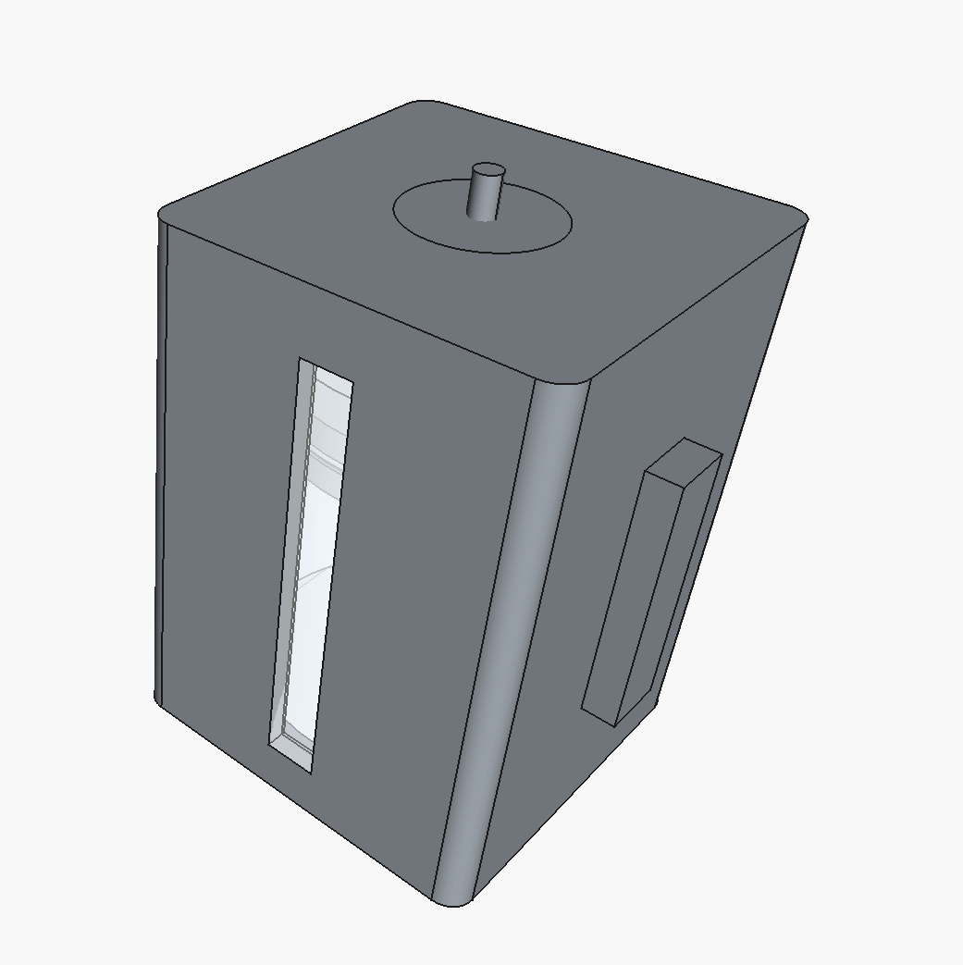

Updated Parts:

| **Part** | **Update** |
| --- | --- |
| **Fill Limit Ring** | Reduce spillage contamination |
| **Guide Rods** | Increased guide rods from 2 to 4, and guide_rod_radius from ~1.2 mm to **1.5 mm** for more stability. |
| **Rod Placement Logic** | Refined rod angle + distance calculation to ensure guide rods are placed **outside the main cylinder**. |
| **Side Handle** | Relocated the side handle to attach flush to the right outer face of the housing (handle_x = housing_size). |
| **Visual Fill Window** | Fill window (cut + panel) was preserved and aligned at front face (window_y = 0). Made Transparent. |
| **Neck Gasket** | Added to prevent leaks |
| **Main Cylinder** | Made transparent |